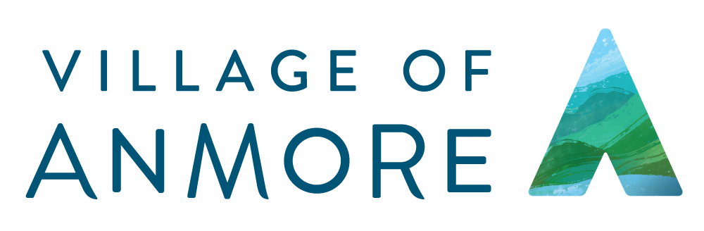
CONTACT US DURING THE COVID-19 MUNICIPAL OFFICE CLOSURE
DURING

Contact Us
**Due to COVID-19, the Village Hall is closed to the public effective March 18 and staff are primarily working from home. We encourage you to submit your queries to village.hall@anmore.com for the quickest response. If you need to speak with someone directly during our regular office hours of 8:30am to 4:00pm, please see the contact list below**

Lance Fortier, Operations Superintendent 604-469-6622 or lance.fortier@anmore.com
For non-emergency queries relating to waste collection carts, water meter reads, roads and parks

Martin Greig, Building Inspector/Bylaw Enforcement Officer 778-886-3419 or martin.greig@anmore.com
For queries relating to building inspections, permits and bylaw enforcement

Jason Smith, Manager of Planning & Development Services 778-875-4032 or jason.smith@anmore.com
For queries related to planning, including subdivision applications

Karen Elrick, Manager of Corporate Services 604-319-9222 or karen.elrick@anmore.com
For queries relating to public meetings & minutes, records and Village emergency plans

Juli Halliwell, Chief Administrative Officer 604-763-3274 or juli.halliwell@anmore.com
For all other queries not listed above

Solid Waste Collection queries are to be sent to village.hall@anmore.com.

COVID-19

